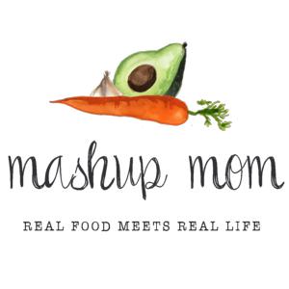
ALDI Meal Plan week of 5/10/20 – Find the recipes at MashupMom.com
Sunday | Sheet pan Parmesan chicken drumsticks w/ carrots & potatoes, watermelon
Monday | Creamy salsa potato soup, Italian bread, watermelon
Tuesday | Smoked sausage tortellini skillet, mixed berries
Wednesday | Chicken & asparagus stir fry, stir fried carrots, rice
Thursday | Thyme for a one pan chicken mushroom rice skillet, broccoli & cheddar
Friday | Sheet pan pesto chicken with asparagus & mushrooms, roasted potatoes
Saturday | Leftovers – pizza night – or carryout

Dairy & refrigerated
Priano shredded Parmesan, $1.99 (Sun, Tues, Fri)
8 oz Happy Farms cheddar, $1.65 (Mon, Thurs)
9 oz Priano three cheese tortellini, $1.99 (Tues)
14 oz Pueblo Lindo verde salsa, $2.49 (Mon)
Grocery
Specially Selected Italian take-and-bake bread, $1.99 (Mon)
Fusia soy sauce, $1.59 (Weds)
3 lbs Earthly Grains long grain white rice, $1.99 (Weds, Thurs)
32 oz Simply Nature organic vegetable broth, $1.89 (Mon)
32 oz Chef’s Cupboard chicken broth, $1.29 (Thurs)
6.7 oz Priano Genovese pesto, $2.29 (Tues, Fri)
Meat
2.5 lbs chicken drumsticks, $3.23 (Sun)
5.25 lbs boneless skinless chicken breast, $9.92 (Weds, Thurs, Fri)
Parkview Polska kielbasa, $2.35 (Tues)

Produce
Whole seedless watermelon, $3.99 (Sun, Mon)
1 lb strawberries, $1.19 (Tues)
Pint blueberries, $1.99 (Tues)
Bunch green onions, $.69 (Mon, Weds)
8 oz baby bella mushrooms, $1.89 (Tues)
2 packs 8 oz mushrooms, $3.38 (Thurs, Fri)
2 lbs carrots, $1.29 (Sun, Mon, Weds)
16 oz broccoli crowns, $1.69 (Tues, Thurs)
2 lbs asparagus, $3.98 (Weds, Fri)
3 lbs yellow onions, $1.69 (Mon, Tues, Thurs, Fri)
3 heads garlic, $1.29 (Tues, Weds, Thurs, Fri)
5 lbs yellow potatoes, $2.99 (Sun, Mon, Fri)

Total: $60.72

Note: The days(s) on the shopping list show which meal(s) an item will be used in. If you are skipping a night, you can easily delete items you don’t need to purchase.

