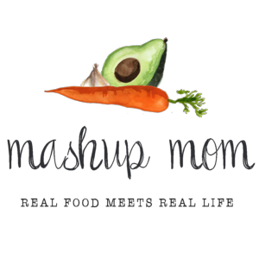
ALDI Meal Plan week of 6/3/18 – Find the recipes at MashupMom.com
Sunday | Paprika pork chop sandwiches, corn on the cob, watermelon
Monday | Grilled cheese & tomato naan, watermelon
Tuesday | Pork & potato sheet pan dinner, asparagus
Wednesday | Turkey taco stuffed potatoes with avocado & mango
Thursday | Smoked sausage, zucchini, & spinach pasta, sourdough toast, garden salad
Friday | Red “pistou” salmon, roasted veggies
Saturday | Leftovers – pizza night – eat out – or date night

Your ALDI Shopping List
Dairy & refrigerated
Shredded Priano Parmesan, $1.99 (Sun, Thurs)
Deli sliced Happy Farms mozzarella, $1.99 (Mon)
8 oz block Happy Farms cheddar, $1.99 (Weds)
Grocery
Specially Selected sourdough square, $2.89 (Sun, Thurs)
Specially Selected naan, $3.79 (Mon)
Priano sun dried tomato pesto, $2.19 (Mon, Fri)
12 oz Reggano rotini, $.79 (Thurs)
8 oz can Happy Harvest tomato sauce, $.29 (Weds)
14.5 oz can Happy Harvest fire roasted diced tomatoes, $.89 (Thurs)
1 can Dakota’s Pride black beans, $.69 (Weds)

Meat
13-14 oz Parview Polska kielbasa (turkey or regular), $2.19 (Thurs)
2.5 lbs thick cut boneless pork chops, $7.48 (Sun, Tues)
19 oz Fit & Active ground turkey, $3.49 (Weds)
32 oz Sea Queen frozen wild caught pink salmon, $7.39 (Fri)
Produce
Four ears sweet corn, $1.16 (Sun)
Watermelon, $3.99 (Sun, Mon)
2 mangoes, $1.18 (Weds)
5 oz SimplyNature organic baby spinach, $1.69 (Thurs)
Little Salad Bar garden salad, $.89 (Thurs)
8 oz baby bella mushrooms, $1.49 (Tues)
16 oz broccoli crowns, $1.39 (Tues, Fri)
1 lb asparagus, $1.99 (Tues)
3 lbs yellow onions, $1.89 (Sun, Weds, Thurs, Fri)
3 heads garlic, $1.19 (Sun, Weds, Thurs)
5 lb baking potatoes, $2.49 (Tues, Weds, Fri)
20 oz zucchini, $1.49 (Thurs, Fri)
4 Roma tomatoes, $.80 (Mon)
1 avocado, $.99 (Weds)

Total: $60.68.

Note: The days(s) on the shopping list show which meal(s) an item will be used in – If you’re skipping a night; easily delete the items you don’t need to purchase.

