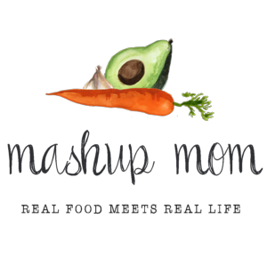
ALDI Meal Plan week of 5/13/18 – Find the recipes at MashupMom.com
Sunday | Slow cooker chicken drumsticks marinara, garlic Parmesan green beans
Monday | Pork & veggie stew, sourdough toast
Tuesday | Sheet pan chicken drumsticks w/ broccoli & potatoes, mixed berries
Wednesday | Roasted asparagus grilled cheese, leftover stew
Thursday | Pesto tortellini w/ chicken, spinach, & tomatoes, salad
Friday | Oven baked pesto tilapia, mashed potatoes & carrots
Saturday | Leftovers – pizza night – eat out – or date night

Your ALDI Shopping List
Dairy & refrigerated
7 oz sliced Havarti, $1.99 (Weds)
8 oz Priano mozzarella, $2.79 (Sun)
5 oz Priano shredded Parmesan, $1.99 (Sun, Weds)
9 oz Priano three cheese tortellini, $1.99 (Thurs)
Grocery
Specially Selected sourdough square, $2.89 (Mon, Weds)
Reggano penne pasta, $.79 (Sun)
Priano pesto, $2.19 (Thurs, Fri)
SimplyNature organic marinara, $2.19 (Sun)
32 oz SimplyNature organic beef broth, $1.89 (Mon)
Can Happy Harvest fire roasted diced tomatoes, $.89 (Mon)
Can Happy Harvest corn, $.48 (Mon)
Can Happy Harvest green beans, $.48 (Mon)

Meat
5 lbs chicken drumsticks, $3.95 (Sun, Tues)
1 lb boneless skinless chicken breast, $2.29 (Thurs)
1.5 lbs boneless thick cut pork chops, $4.49 (Mon)
32 oz Sea Queen frozen tilapia, $5.49 (Fri)
Produce
8 oz spinach, $1.49 (Thurs)
Garden salad, $.89 (Thurs)
2 lbs carrots, $.99 (Mon, Fri)
Two 8 oz baby bella mushrooms, $1.98 (Sun, Mon)
1 lb broccoli crowns, $1.19 (Tues)
1 lb asparagus, $1.99 (Weds)
1 lb strawberries, $1.49 (Tues)
Pint blueberries, $2.29 (Tues)
3 heads garlic, $1.19 (Sun, Mon, Tues, Thurs)
3 lbs yellow onions, $1.89 (Mon)
5 lbs gold potatoes, $3.99 (Mon, Tues, Fri)
1 lb green beans, $1.29 (Sun)
Celery, $1.29 (Mon)
Pint grape tomatoes, $1.29 (Thurs)

Total: $60.03

Note: The days(s) on the shopping list show which meal(s) an item will be used in – If you’re skipping a night; easily delete the items you don’t need to purchase.

