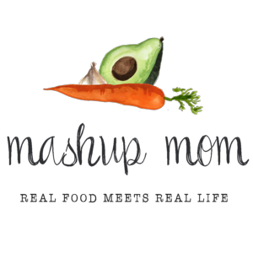
ALDI Meal Plan week of 4/29/18 – Find the recipes at MashupMom.com
Sunday | Simple skillet chicken drumsticks, skillet potatoes & green beans, blueberries
Monday | Summer squash & tomato frittata, avocado, cantaloupe
Tuesday | Cheesy garlic chicken drumsticks, pineapple, roasted chipotle potatoes
Wednesday | Easy beef, tomato, & spinach tortellini, baguette, salad
Thursday | Sheet pan sausage, green bean, potato dinner, salad with grape tomatoes
Friday | Panko tilapia, crispy baked zucchini chips, salad
Saturday | Leftovers – pizza night – eat out – or date night

Your ALDI Shopping List
Dairy & refrigerated
Dozen Goldhen eggs, $1.98 (Mon, Fri)
16 oz Friendly Farms sour cream, $1.49 (Mon, Tues)
8 oz block Happy Farms sharp cheddar, $1.99 (Mon, Tues)
9 oz Priano three cheese tortellini, $1.99 (Weds)
Priano Parmesan wedge, $3.79 (Tues, Weds, Thurs, Fri)
Grocery
Specially Selected baguette, $1.69 (Weds)
Pueblo Lindo chipotles in adobo, $.99 (Mon, Tues)
Chef’s Cupboard whole wheat panko, $1.49 (Tues, Fri)
Meat
Parkview or Fit & Active kielbasa, $2.29 (Thurs)
5 lbs chicken drumsticks, $3.95 (Sun, Tues)
1 lb 80/20 ground beef, $2.99 (Weds)
24 oz tilapia, $8.69 (Fri)
Produce
Cantaloupe, $1.49 (Mon)
Pineapple, $1.29 (Tues)
5 oz SimplyNature organic baby spinach, $2.49 (Weds)
SimplyNature organic 16 oz spring mix salad, $3.79 (Weds, Thurs, Fri)
Cilantro, $.69 (Tues)
Pint blueberries, $2.99 (Sun)
3 heads garlic, $1.19 (Sun, Mon, Tues, Weds, Thurs)
3 lbs yellow onions, $1.69 (Mon, Weds, Thurs)
5 lb red potatoes, $3.29 (Sun, Tues, Thurs)
20 oz zucchini, $1.19 (Mon, Fri)
20 oz yellow squash, $1.19 (Mon, Fri)
16 oz green beans, $1.19 (Sun, Thurs)
2 pints organic grape tomatoes, $3.38 (Mon, Weds, Thurs)
Avocado, $.69 (Mon)

Total: $50.98

Note: The days(s) on the shopping list show which meal(s) an item will be used in – If you’re skipping a night; easily delete the items you don’t need to purchase.

