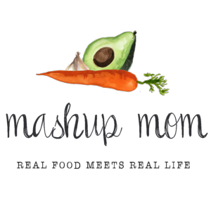
ALDI Meal plan week of 7/16/17 – Find the recipes at MashupMom.com
Sunday | Roasted chicken & vegetables, cherries
Monday | Zuppa Toscana inspired cream of mushroom soup, baguette, organic spring mix salad
Tuesday | Chipotle turkey tacos, cantaloupe
Wednesday | Pasta w/ sausage & kale, sautéed whole mushrooms
Thursday | Chipotle turkey chili, tortilla chips, blueberries
Friday | Steak salad, quesadillas
Saturday | Leftovers – pizza night – eat out – or date night

Shopping list (through 7/15)
Dairy & refrigerated
16 oz Countryside Creamery heavy cream, $1.69
12 oz Happy Farms sharp shredded cheddar, $1.89
Priano shredded Parmesan, $1.99
Grocery
Pueblo Lindo chipotles in adobo, $.99
SimplyNature organic 32 oz vegetable stock, $1.79
Two cans Happy Harvest fire roasted diced tomatoes, $1.78
SimplyNature organic black beans, $.89
Dakota’s Pride kidney beans, $.55
8 oz can Happy Harvest tomato sauce, $.25
16 oz SimplyNature organic spaghetti, $1.19
SimplyNature organic balsamic vinaigrette, $1.99
Specially Selected baguette, $1.49
Clancy’s tortilla chips, $1.19
El Milagro flour tortillas, $.89

Meat & seafood
3 lbs Jennie-O 85% lean ground turkey, $5.99
19 oz spicy Italian sausage, $1.99
1 lbs top sirloin steak, $4.99
5 lb whole chicken, $4.75
Produce
3 pack multi-colored peppers, $1.79
3 lbs yellow onions, $1.69
Three packs 8 oz mushrooms, $2.07
3 heads garlic, $1.19
5 lbs baking potatoes, $1.99
12 oz SimplyNature organic chopped kale, $3.49
3 pack romaine hearts, $1.99
Hass avocado, $.89
Cantaloupe, $.99
16 oz Roma tomatoes, $.99
16 oz SimplyNature organic spring mix, $2.99
Pint blueberries, $1.49
16 oz baby carrots, $.69
16 oz Washington red cherries, $1.49

Total: $60.03

