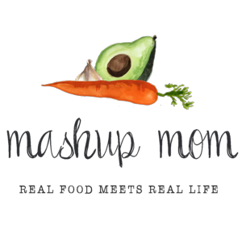
ALDI Meal plan week of 6/18/17 – Recipes at MashupMom.com
Sunday | Pokemon Pizza Burgers, strawberries, potato chips, corn on the cob
Monday | Southwest Quinoa Unstuffed Peppers, grapes, strawberries
Tuesday | Southwest Quinoa Quesadillas, grapes, baby carrots
Wednesday | Crock-Pot Ribs, salad w/ olives & pepperoni, corn on the cob
Thursday | Sheet Pan Drumsticks & Veggies, spinach salad w/ Parmesan
Friday | Slow Cooker Garlic Chicken Drumsticks, Parmesan-garlic quinoa, broccoli
Saturday | Leftovers – pizza night – eat out – or date night

Shopping list (through 6/17)
Dairy & refrigerated
16 oz Happy Farms mild shredded cheddar, $2.99
Priano shredded Parmesan tub, $1.99
Priano 8 oz mozzarella, $1.99
Grocery
Dakota's Pride black beans, $.59
Happy Harvest fire roasted diced tomatoes, $.89
Pueblo Lindo mild chopped green chiles, $.65
32 oz SimplyNature organic vegetable broth, $1.79
16 oz SimplyNature organic quinoa, $3.49
El Milagro 12 ct flour tortillas, $.85
Casa Mamita mild salsa, $1.49
2 liter Summit cola, $.85
Burman's organic BBQ sauce, $1.99
L'Oven Fresh hamburger buns, $.85
Tuscan Garden can black olives, $1.19
Clancy's potato chips, $1.09
Specially Selected vinaigrette, $1.89
Meat & seafood
4 lbs chicken drumsticks, $2.76
3 lbs St. Louis spare ribs, $5.97
Mama Cozzi sliced pepperoni, $2.19
2 lbs 80/20 hamburger, $5.58
Produce
3 heads garlic, $1.19
3 lbs yellow onions, $1.69
2 four-packs sweet corn, $2.58
3 pack green peppers, $.99
1 avocado, $.99
2 lbs red grapes, $1.98
2 lbs strawberries, $2.58
16 oz baby carrots, $.99
8 oz baby bella mushrooms, $1.49
16 oz broccoli crowns, $1.49
8 oz bagged spinach, $1.49
Bagged salad of choice, $1.99
---
$60.53

